Common Subsequence
Time Limit: 2000/1000 MS (Java/Others) Memory Limit: 65536/32768 K (Java/Others)
Total Submission(s): 22539 Accepted Submission(s): 9886
Problem Description
A subsequence of a given sequence is the given sequence with some elements (possible none) left out. Given a sequence X = <x1, x2, ..., xm> another sequence Z = <z1, z2, ..., zk> is a subsequence of X if there exists a strictly increasing sequence <i1, i2, ..., ik> of indices of X such that for all j = 1,2,...,k, xij = zj. For example, Z = <a, b, f, c> is a subsequence of X = <a, b, c, f, b, c> with index sequence <1, 2, 4, 6>. Given two sequences X and Y the problem is to find the length of the maximum-length common subsequence of X and Y.
The program input is from a text file. Each data set in the file contains two strings representing the given sequences. The sequences are separated by any number of white spaces. The input data are correct. For each set of data the program prints on the standard output the length of the maximum-length common subsequence from the beginning of a separate line.

Sample Input
abcfbc abfcab
programming contest
abcd mnp

Sample Output
4
2
0

Source
Southeastern Europe 2003

Recommend
Ignatius | We have carefully selected several similar problems for you: 1176 1058 1069 1421 1203

Statistic | Submit | Discuss | Note

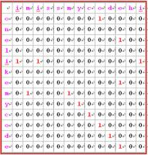
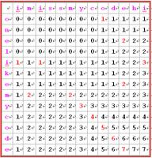
#include <iostream>
#include <cstring>
using namespace std;
char str1[100],str2[100];int str[100][100];
int main()
{
int len1,len2,i,j;

while(cin>>str1>>str2)
{ len1=strlen(str1);
len2=strlen(str2);
//cout<<len1<<" "<<len2<<endl;
for(i=1;i<len1+1;i++)
for(j=1;j<len2+1;j++)
{
if(str1[i-1]==str2[j-1])
str[i][j]=str[i-1][j-1]+1;
else
str[i][j]=str[i-1][j]>str[i][j-1]?str[i-1][j]:str[i][j-1];
}
/* int max=0;
for(i=1;i<len1+1;i++)
{ cout<<endl;
for(j=1;j<len2+1;j++)
cout<<str[i][j]<<" ";
}
*/
cout<<str[len1][len2]<<endl;
}
return 0;
}

